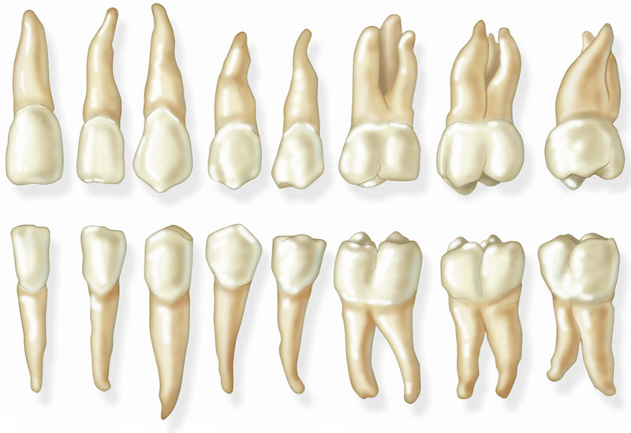

HUMAN DENTAL ANATOMY
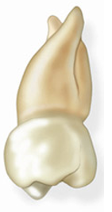 | 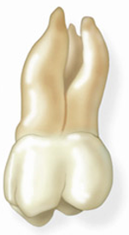 | 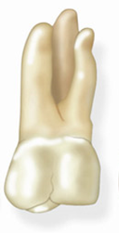 | 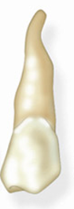 | 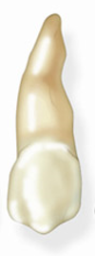 | 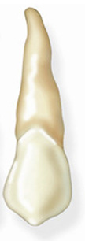 | 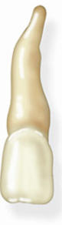 | 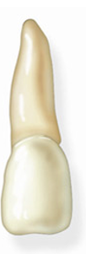
18 | 17 | 16 | 15 | 14 | 13 | 12 | 11 | 21 | 22 | 23 | 24 | 25 | 26 | 27 | 28
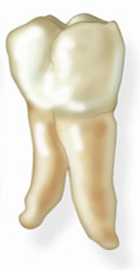 | 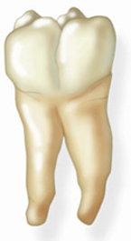 | 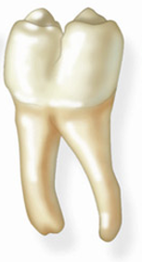 | 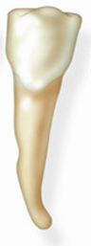 | 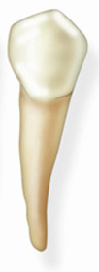 | 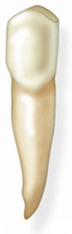 | 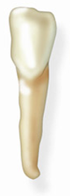 | 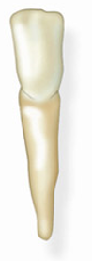
48 | 47 | 46 | 45 | 44 | 43 | 42 | 41 | 31 | 32 | 33 | 34 | 35 | 36 | 37 | 38

